**Task 1: LED blinking using my RIO** 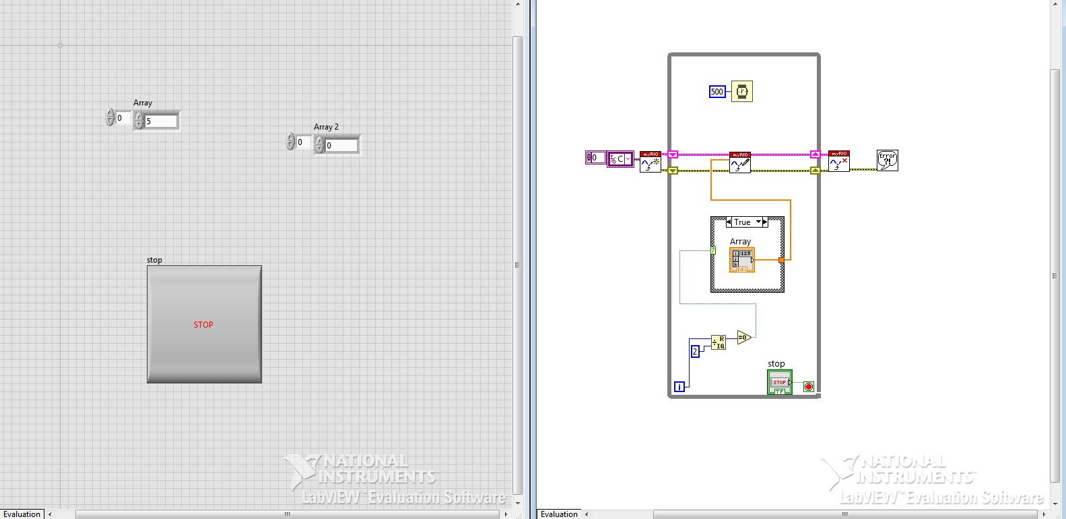

**Task 2: Accelerometer using my_RIO**

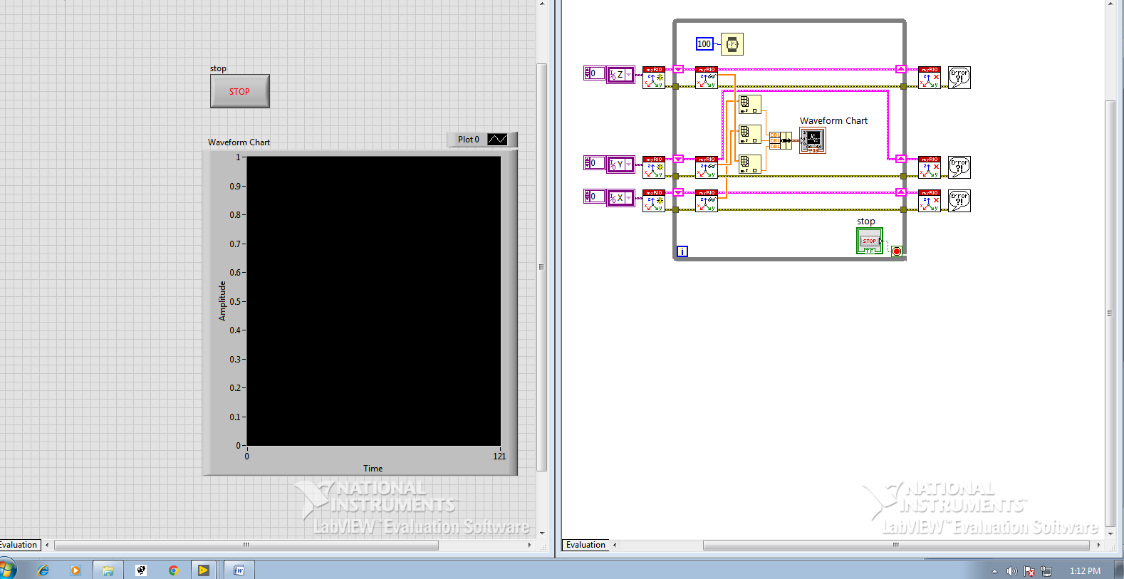

**Task 3: Relay interfacing to my RIO**

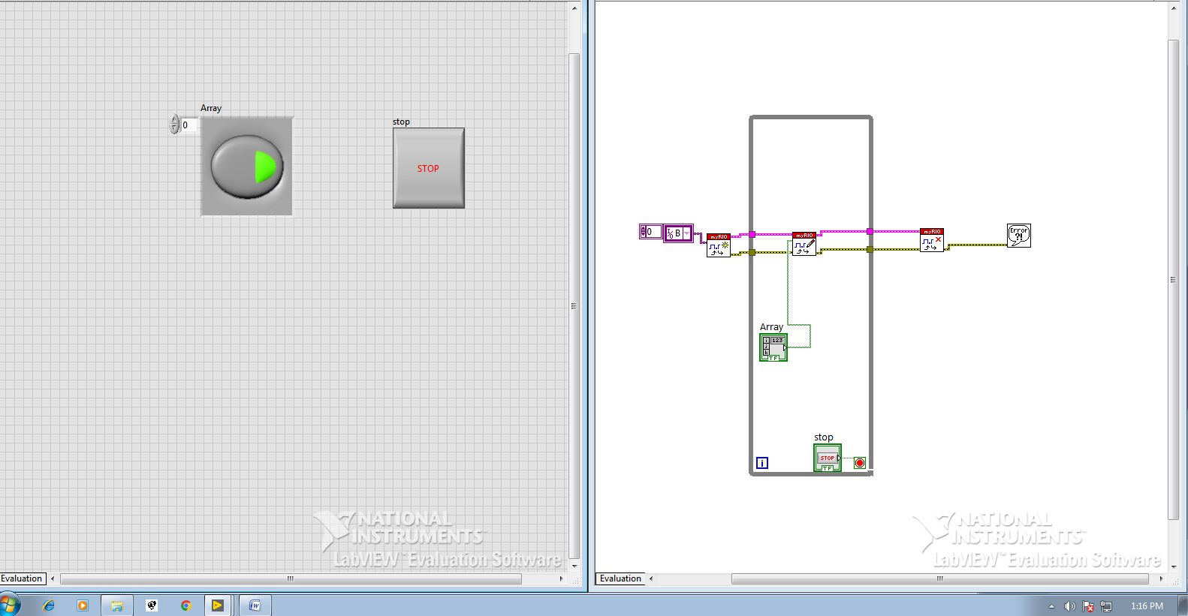

**Task 4: IR sensor interfacing to my RIO**

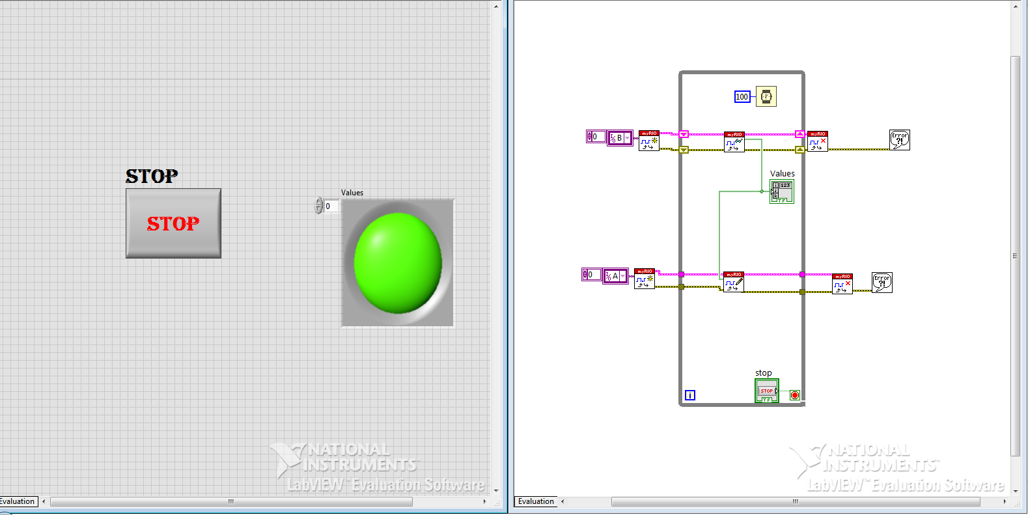

**Task 5 : PWM USING MY RIO**

